Physical Security Highlights

Natural Surveillance is desirable. No security through Obscurity. Business should be located where the public can see them easily. Criminals like to be “invisible.”

Fences: 8 feet high **DETER** determined intruders—no height will prevent them. Fences are preferred over walls (walls offer no visibility)

Bollards are designed to prevent attacks with vehicles

Gates:

* Category 1: Residential—ornamental in design
* Category 2: Commercial: Expects frequent access but provides higher security than category 1
* Category 3: Industrial: Limited, infrequent access
* Category 4: Military and Government—most secure

Lighting: 8 feet high and provide 2 “foot-candles” (Lumens per square foot)

CPTED: Crime Prevention Through Environmental Design: Use physical characteristics to secure your facility like building materials, landscaping, maintenance to influence security—see day 4 or day 5 document called CPTED.

Doors: Hinges to be internal to the door itself. Not inside or outside.

Windows: Polycarbonate (Lexan)—bullet resistant

HVAC: Positive Flow…smoke should flow out of rooms, not in. Temperature in server rooms should be 70 degrees or cooler

Humidity: Around 50%. Too much leads to condensation and rust. Too little causes static electricity.

Data centers should not be located in basement (flood risk) 1st floor (traffic) top floor (fire). Middle floors are best away from restrooms and elevators

Walls should go to the true ceiling instead of drop ceiling.

CCTV should provide PTZ (pan, tilt, zoom), automatic iris (adjust to changes in light)—provide detection, though their placement can provide deterrence

Doors should always fail soft or safe to protect human life.

Security Guards provide best defense against piggy backing.

Alarm systems: Electro-mechanical rely upon a connection being broken. Volumetric are more expensive—proximity, motion detectors, photoelectric (require an environment with no windows.) Acoustic systems are often designed to respond only to certain frequencies like breaking glass, so they may be used even in environments that can be noisy.

Power: EMI is frequently caused by improper grounding

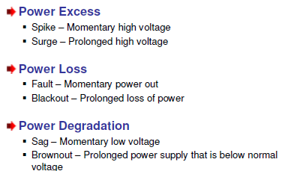

Fire Safety: Class C fire extinguishers for electrical fires. Most people get questions on types of sprinklers: Pre-action is best for Data Center



